# A Password Change Required on First Login

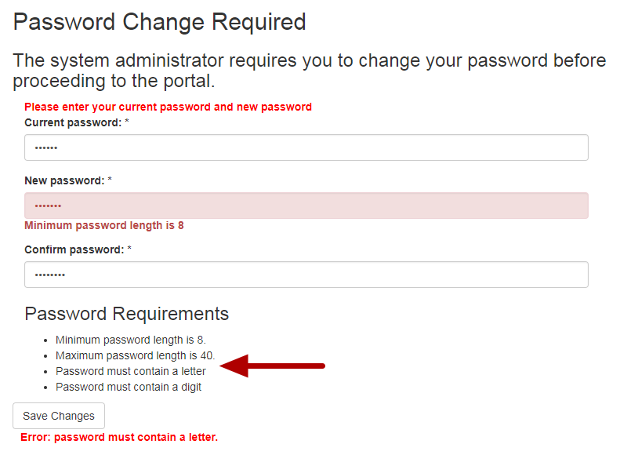

The first time that you login to the new Pathway, you will be required to change your password. Your new password must be between 8-40 characters long and contain at least one letter and number. Validation warnings are displayed in red to help you complete the form.

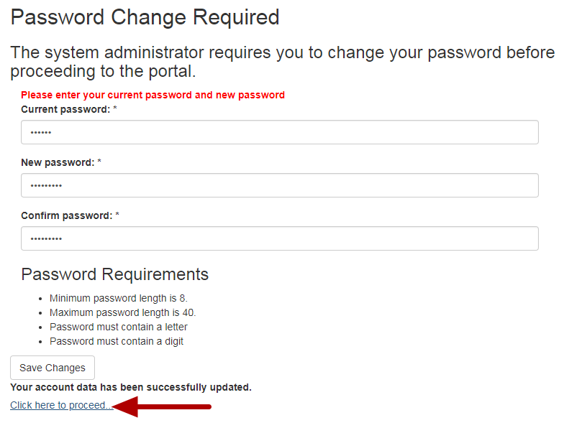

After you change your password, click on the link that says "**Click here to proceed**."