# How to Access your Online Classes on Canvas

All online courses offered here at Clovis Community College exist in Canvas and some face-to-face courses may have some assignments in Canvas. Check with your instructor the first day of classes to find out if there are any assignments that require logging into and using Canvas.

## Click on the Canvas icon in the upper right-hand side of the screen

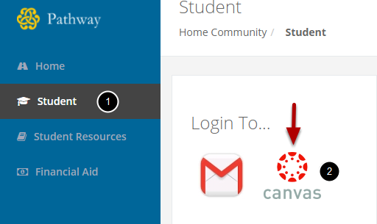

1. From the Student Page...

2. Click on the Canvas icon.

Canvas is our online Learning Management System (LMS). All of CCC's online courses are taught in Canvas. Canvas can be accessed directly at <http://cloviscc.instructure.com>.

## Access your courses through the Courses & Groups pull-down menu

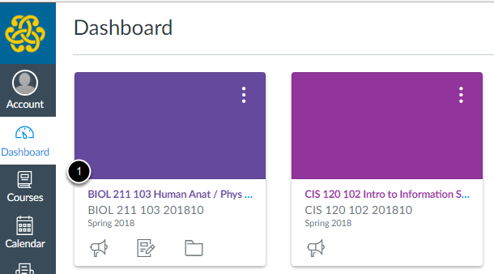

1. Click on the title of the course you want to access

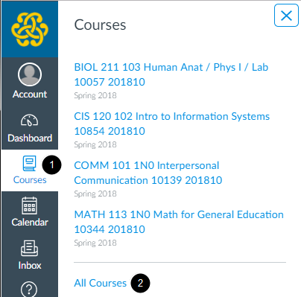

If you don't see all of your courses on the Dashboard, click on the "**Courses**" navigation link then click on the "**All Courses**" link.

1. Click on "**Courses**"

2. Click on "**All Courses**"

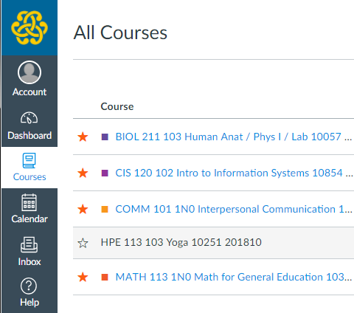

Starred courses display on the Dashboard. Click on the star next to a Course to add or remove it from the Dashboard.