# How to Access your Student Email

Clovis Community College uses the Student Email system as our primary means of contacting students. You should check your Student Email account frequently.

## Click on the Student Email Icon

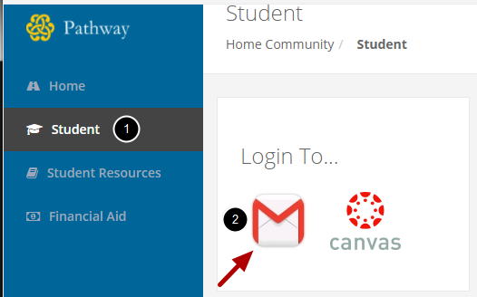

1. On the Student Page...

2. Click on the Student Email Icon on the right hand side of the screen.

CCC uses Gmail for its student email system. The first time you access your Student Email account, you will have to agree to Gmail's Terms of Service.