# How to Change your Password Recovery Answers

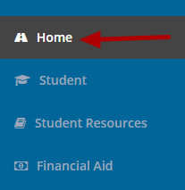

To change your Password Recovery Answers, click on the **Home** page.

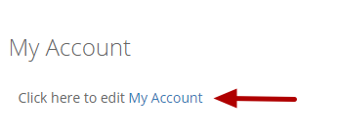

Click on the "**My Account**" link in the My Account box.

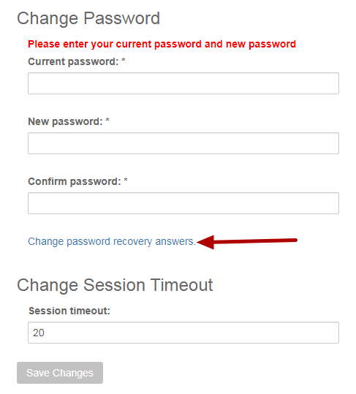

Click on the "**Change password recovery answers**" link.

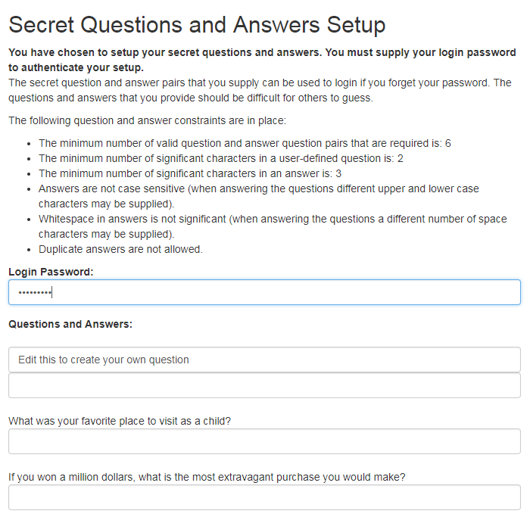

Enter your password and change your answers.

**The following question and answer constraints are in place:**

**The minimum number of valid question and answer question pairs that are required is: 6. You must answer at least 6 questions.**

**The minimum number of significant characters in a user-defined question is: 2. Each answer must be at least 2 characters long.**

**The minimum number of significant characters in an answer is: 3.**

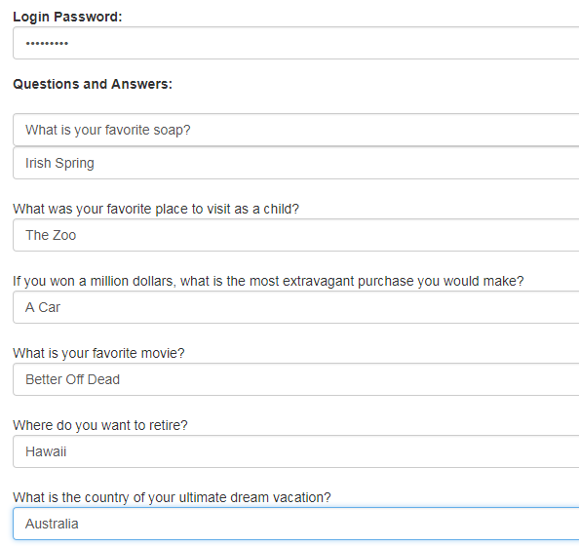

**Answers are not case sensitive (when answering the questions different upper and lower case characters may be supplied).**

**The system treats "Ice Cream" and "ice cream" the same.**

**Whitespace in answers is not significant (when answering the questions a different number of space characters may be supplied).**

**The system treats "Ice Cream" and "Ice Cream" the same.**

**Duplicate answers are not allowed. Answers cannot be repeated. Each answer must be different.**

**There are 3 questions that you can edit to make your own questions.**

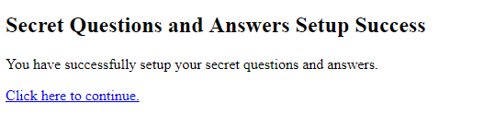

Click on the "**Click here to continue**" link to continue.