# How to Change your Password

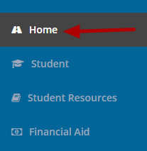

To change your Pathway password, click on the **Home** page.

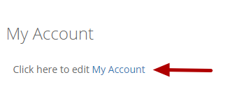

Click on the "**My Account**" link in the My Account box.

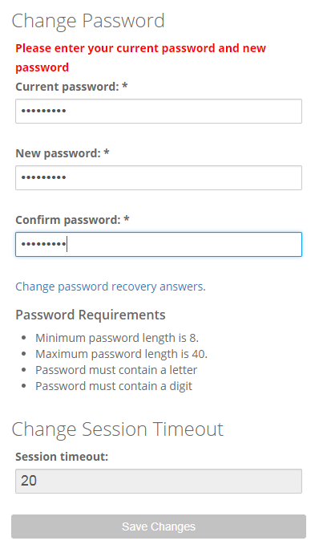

Ener your old password and a new password that conforms to the password requirements. Enter the new password again for confirmation. Click on the "**Save Changes**" button.