# How to Find your Student ID/C Number

## Click on Student Detail Schedule

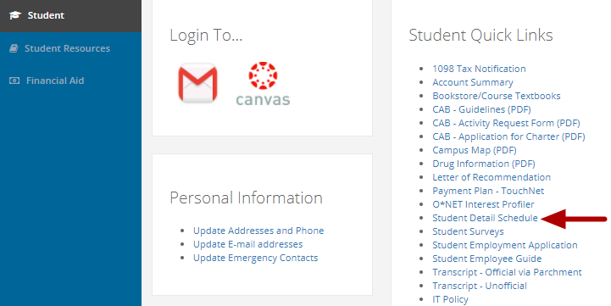

Click on "Student Detail Schedule" in the "Student Quick Links" box, the first box in the middle column.

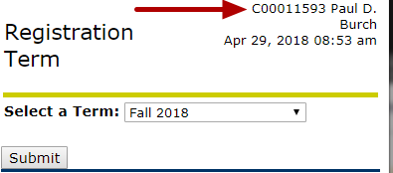

Your Student ID/C Number is listed in the top, left-hand side.