# How to Log In

Pathway uses the same login page, username and password that is used by the CCC student email system, and Canvas, our online Learning Management System (LMS).

The first time that you login, you will be asked to change your password and answer six security questions. If you ever forget your password, you will need to answer three of these security questions before the system will allow you to reset your password.

**Note: To avoid possible problems, please do not use the Internet Explorer web browser the first time that you log in. Internet Explorer using Compatibility View displays the change password page as a blank page. You can use Internet Explorer after you can successfully changed your password and set security questions.**

## How to Login

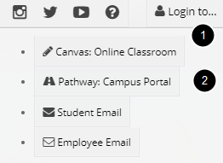

To login to Pathway, enter <http://pathway.clovis.edu> in your web browser address or URL field.

The [www.clovis.edu](http://www.clovis.edu) website also contains links to Pathway.

1. Click on the **Login to..**.navigation menu in the top right-hand side of the window

2. Select **Pathway Campus Portal**

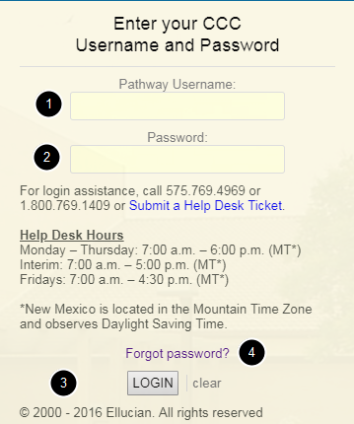

1. Enter your **User Name**

2. Enter your **Password** *

3. Click on the **Login** button

* The default password is your birth date in MMDDYY format; however, you will be forced to change your password the first time you log in.

4. If you forget your password, click on the **Forgot password** link. You will be able to reset your password after answering three security questions.

For login assistance, call 575.769.4969 or 1.800.769.1409

Monday – Thursday: 7:00 a.m. – 6:00 p.m. (MT*)

Interim: 7:00 a.m. – 5:00 p.m. (MT*)

Fridays: 7:00 a.m. – 4:30 p.m. (MT*)

*New Mexico does observe Daylight Saving Time.

or [Submit a Help Desk Ticket](http://www.clovis.edu/helpdesk/forms/index.asp)