# How to Reset a Forgotten Password

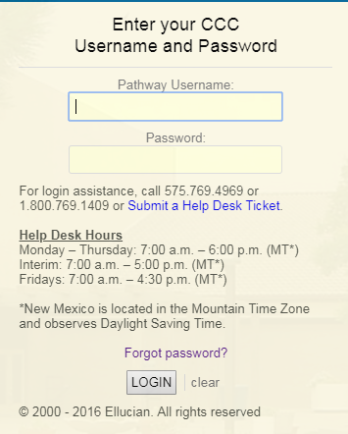

From the login page, click on the "Forgot password?" link.

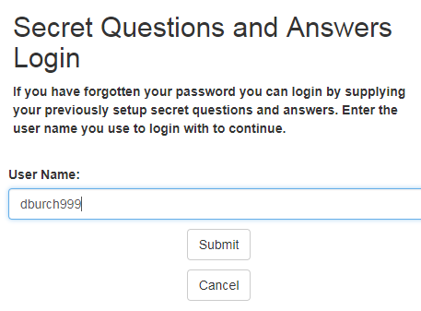

Enter your **User Name** and click on the **Submit** button.

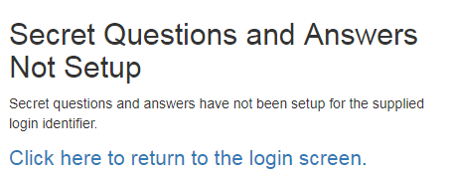

You must contact the Help Desk if you have not set up your Password Recovery Secret Questions and Answers.

For assistance, call 575.769.4969 or 1.800.769.1409

Monday – Thursday: 7:00 a.m. – 6:00 p.m. (MT*)

Interim: 7:00 a.m. – 5:00 p.m. (MT*)

Fridays: 7:00 a.m. – 4:30 p.m. (MT*)

*New Mexico does observe Daylight Saving Time.

or [Submit a Help Desk Ticket](http://www.clovis.edu/helpdesk/forms/index.asp)

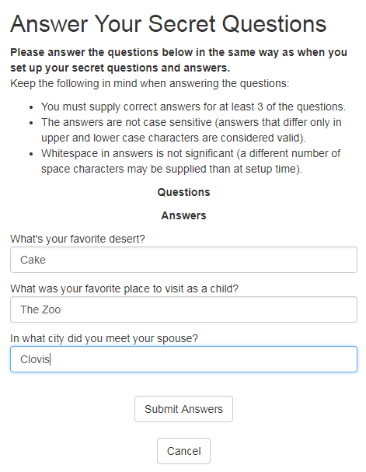

Answer your Password Recovery Secret Questions and Answers. Answers are not case sensistive and extra spaces are ignored.

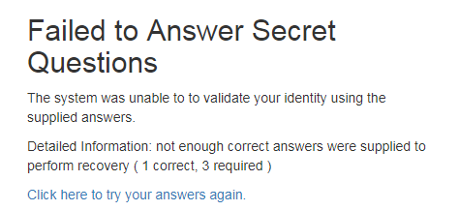

You will be required to provide the correct answers to three questions.

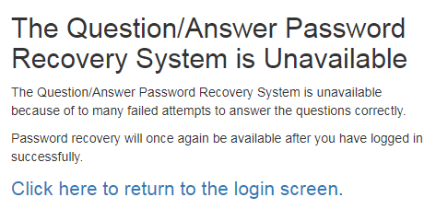

The system will lock your account after too many failed attempts to recover your password. If your account is locked, you must contact the Help Desk if you have not set up your Password Recovery Secret Questions and Answers.

For assistance, call 575.769.4969 or 1.800.769.1409

Monday – Thursday: 7:00 a.m. – 6:00 p.m. (MT*)

Interim: 7:00 a.m. – 5:00 p.m. (MT*)

Fridays: 7:00 a.m. – 4:30 p.m. (MT*)

*New Mexico does observe Daylight Saving Time.

or [Submit a Help Desk Ticket](http://www.clovis.edu/helpdesk/forms/index.asp)

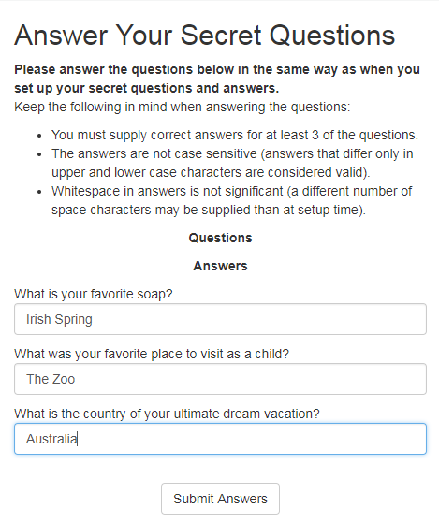

You will see a different set of questions each time, but some will be repeated.

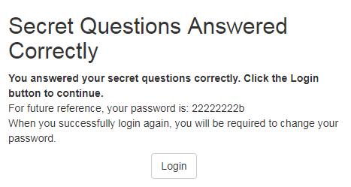

If you correctly answer your secret questions, the system will display your password. Click on the **Login** button to login.

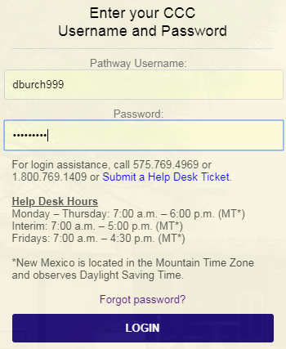

Enter your Username and Password.

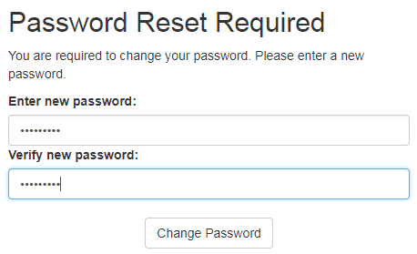

The system will require a password reset after logging in. Enter a new password, enter it again for confirmation, and click on the **Change Password** button.

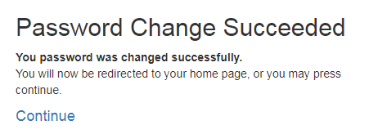

Click on the **Continue** button to proceed to Pathway.

