# How to View your Student Detailed Schedule

## Click on Student Detail Schedule

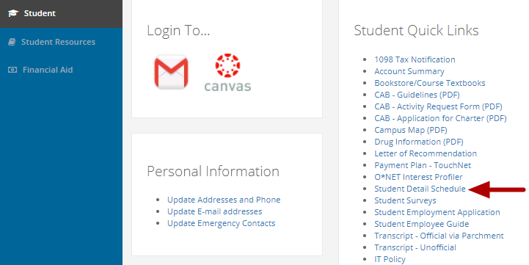

Click on "Student Detail Schedule" in the "Student Quick Links" box (the first box in the middle column).

## Select the Term

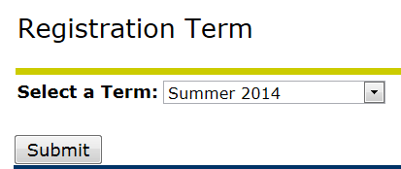

Select the term from the pull-down menu and click on the "Submit" button.

## View your Course Schedule

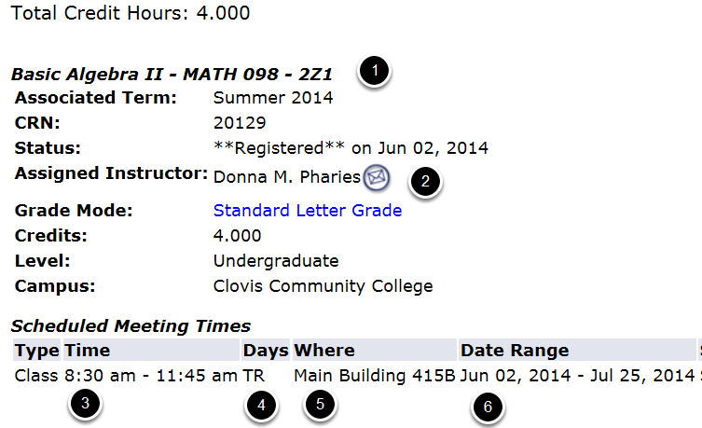

1. Course title

2. Instructor's name and email address

3. Time the class meets

4. Days of the week that the class meets

5. Where the class meets

6. First and last day of class