# Pathway has a New Look

## Old Pathway

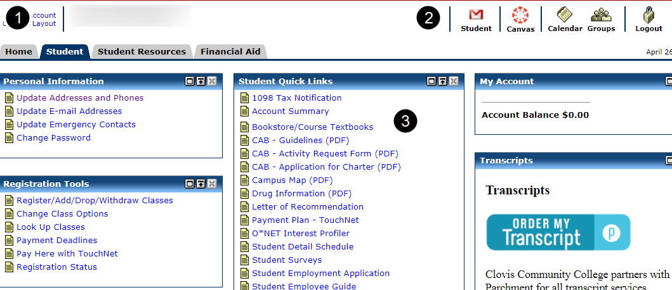

1. Tabs across the top organize content by user type and purpose: Home, Student, Student Resources, etc.

2. Icons to login to Student email and Canvas are on the right-hand side of the top navigation bar.

3. Links to content appear in columns below the tabs.

## New Pathway

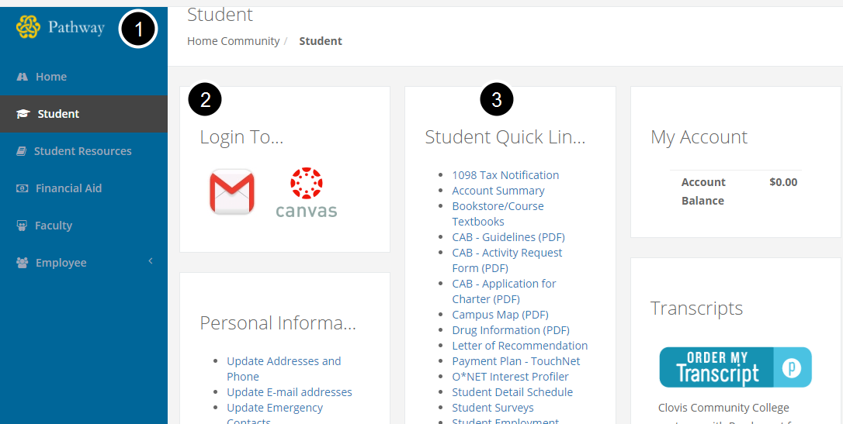

1. Pages along the left-hand sidebar organize content by user type and purpose: Home, Student, Student Resources, etc.

2. Icons to login to Student email and Canvas appear in the first column.

3. Links to content appear in columns to the right of the navigation sidebar.

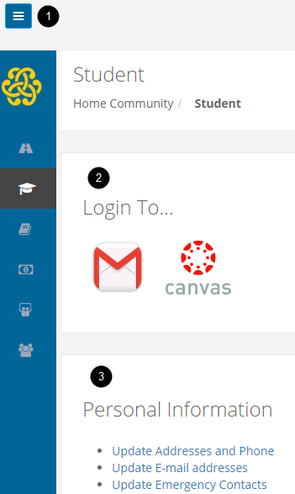

The new Pathway uses a mobile-responsive theme that changes to fit different display sizes.

On Desktops with large monitors, Pathway will show the names of pages in the left-hand navigation sidebar and display content in multiple columns on the right-hand side.

On smaller-width screens, like smaller monitors, tablets, phones, and other mobile devices, a "hamburger" (or triple bar ☰) navigation menu icon appears in the top left-hand corner. Clicking on the navigation menu icon (☰) opens and closes the page menu. Due to limited space, the page titles are replaces with icons that represent that page: A path icon for the Pathway Home page; A graduation cap icon for the Student page; A book icon for the Student Resources page; And a money icon for the Financial Aid page.

On smaller-width screens, multiple columns are displayed in one column. Scrolling down will display all the content in this order: The left-most column will be displayed first, followed by the middle column, if there is one, and the right-most column will be last.