# Secret Questions and Answers Setup on First Login

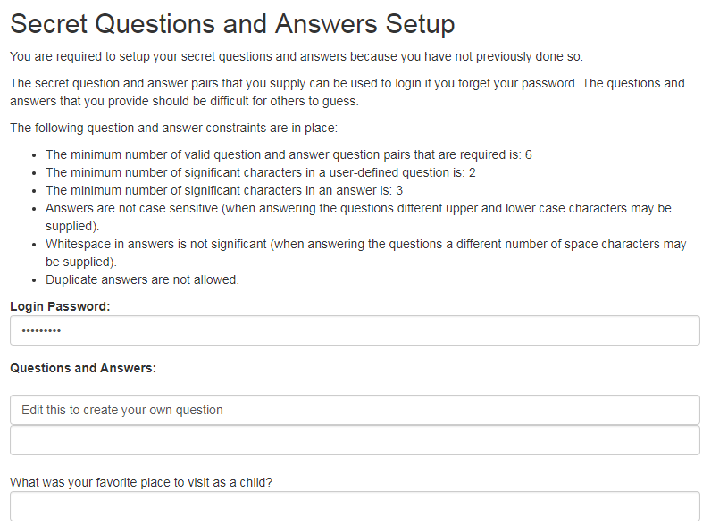

You are required to setup secret questions and answers on your first login.

The secret question and answer pairs that you supply can be used to login if you forget your password. The questions and answers that you provide should be difficult for others to guess.

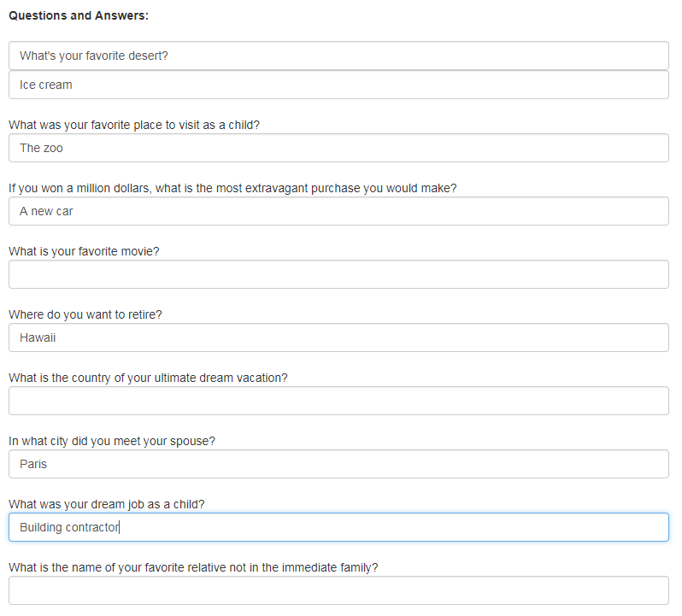

**The following question and answer constraints are in place:**

**The minimum number of valid question and answer question pairs that are required is: 6. You must answer at least 6 questions.**

**The minimum number of significant characters in a user-defined question is: 2. Each answer must be at least 2 characters long.**

**The minimum number of significant characters in an answer is: 3.**

**Answers are not case sensitive (when answering the questions different upper and lower case characters may be supplied).**

**The system treats "Ice Cream" and "ice cream" the same.**

**Whitespace in answers is not significant (when answering the questions a different number of space characters may be supplied).**

**The system treats "Ice Cream" and "Ice Cream" the same.**

**Duplicate answers are not allowed. Answers cannot be repeated. Each answer must be different.**

**There are 3 questions that you can edit to make your own questions.**

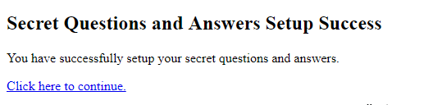

Click on the "**Click here to continue**" link to continue to Pathway.

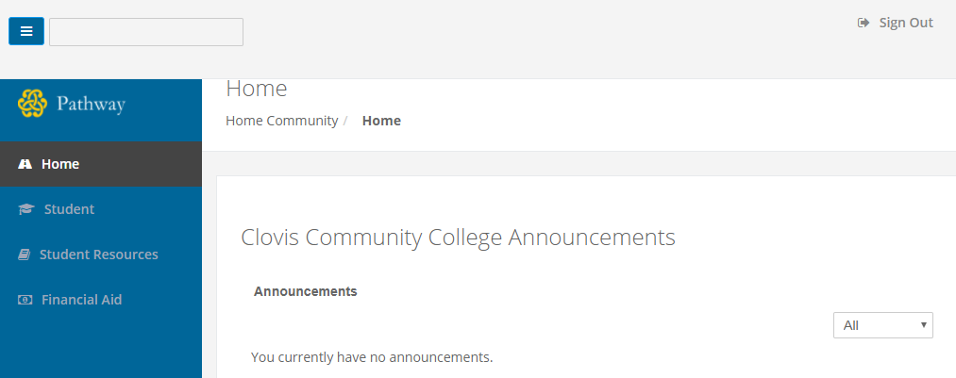

After clicking continue, you should be logged in to Pathway.